
Panmure District School News
P O Box 14-249, Panmure
87 Mount Wellington Highway
Mount Wellington
Auckland, 1741
Telephone: 527 7659
Facsimile: 527 7089
Email: office@panmure.school.nz

No.03 - Term.4, Week 03 –Monday 30 October 2017

Greetings, Kia ora, Talofa lava, Kia orana, Malo e lelei, Fakalofa Lahi Atu, Namaste, An Young Haseyo, Konichiwha, Bula Vinaka, Sawadee, Dobra Dan, Ni Hao, As-salamu alaykum, Hola

Tokelauan Language Week
Last week, children had the opportunity to learn about Tokelauan Language. Children are enjoying learning about the different language weeks.

Tamaki Zone Touch Tournament

Touch tournament is held this Thursday 02 November.
Venue: Mount Wellington War Memorial Reserve Dunkirk Road in Panmure
Time: 9.30am to 2.00pm

The whanau is welcome to come and support our sports enthusiasts at the games by boosting their team spirit and energy.

Special Awards Duffy Assembly
Congratulations to our wonderful grandma Rachel Hepana. Mrs Hepana was recognised for her wonderful support of the school and of her beautiful moko: Marshall Karma and Summa.
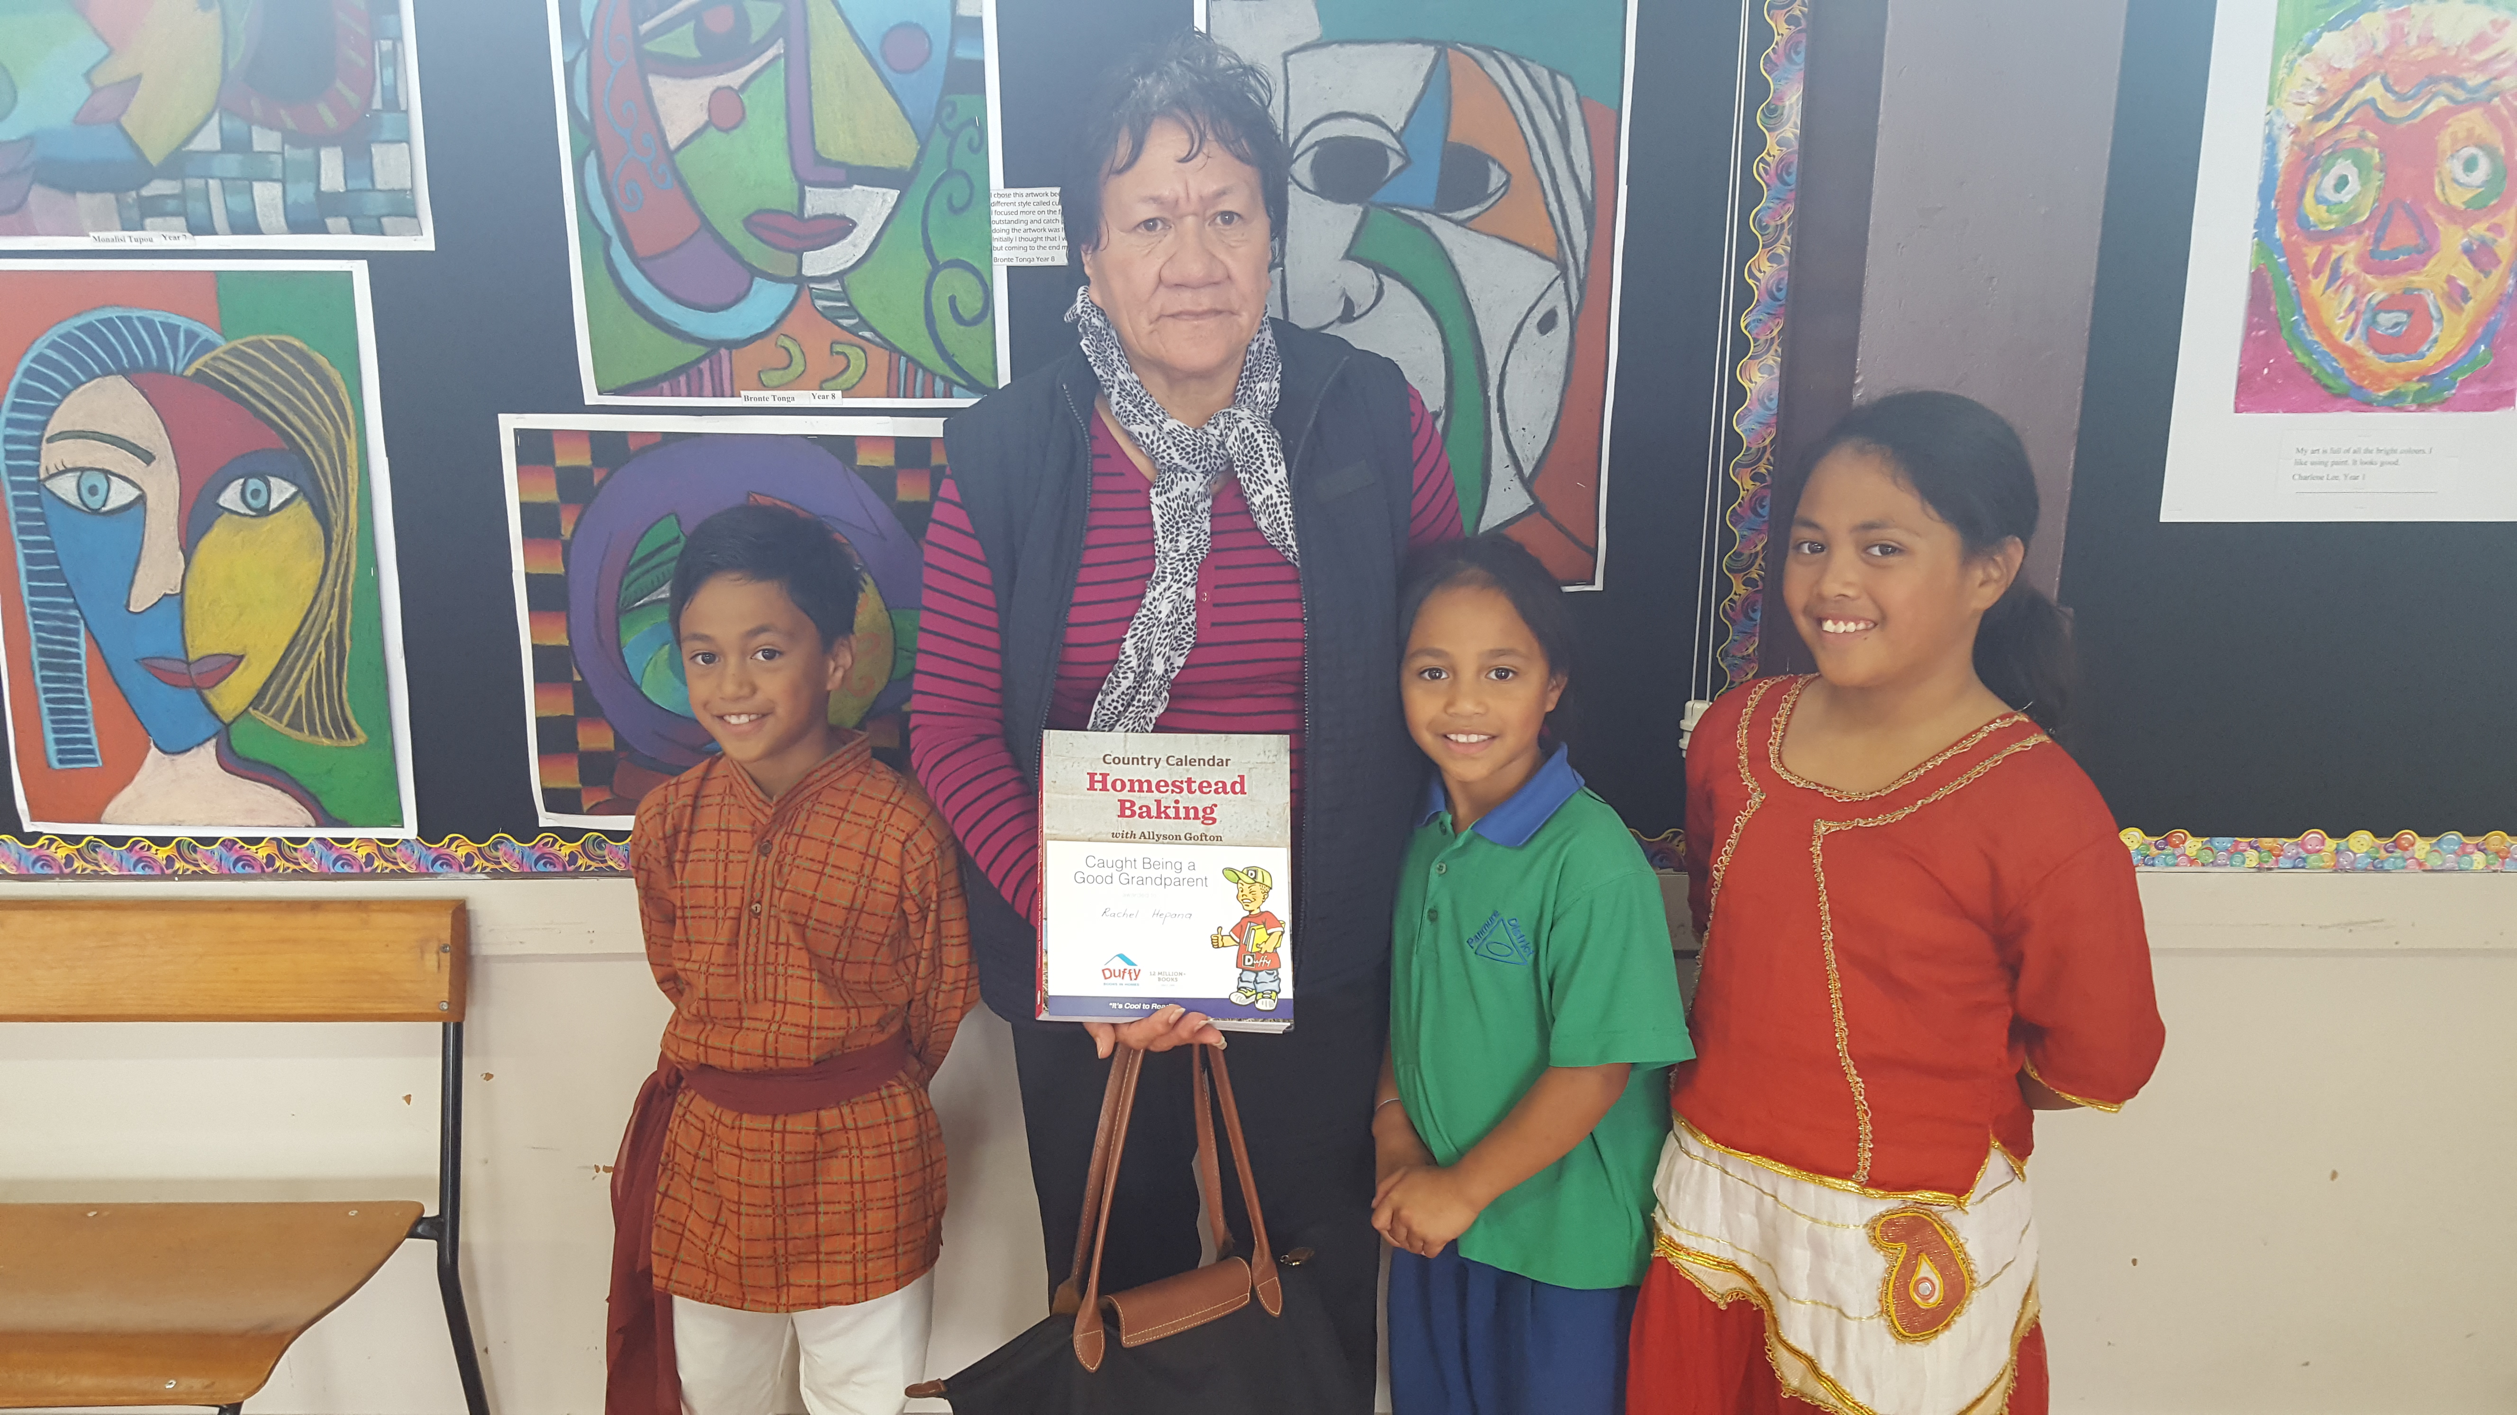

PANMURE DISTRICT SCHOOL REUNION
A reminder to all families of current and ex-pupils to attend this lovely event. An exciting day to cherish memories of your school days at Panmure District School. If you are interested please contact the office for information on how to register. There will also be a special dinner and dance. The reunion is on Saturday 25 November.


Panmure District School Baking Programme
The baking programme starts at 9.00am every Wednesday in the school hall. Parents are welcome to share some of their amazing baking skills as well as socialise with each other.


School Breakfast Club
The breakfast programme runs daily in the school hall at 8.30am for all children who are interested in having breakfast. Parents are welcome to come along.


One Tree Hill College Cyber Safety Evening
The One Tree Hill College PTA is hosting a Cyber Safety Evening in the Art Lobby of One Tree Hill College on Tuesday 7 November at 6.30pm. It is open to all the Maungakiekie Community of Learning families.
There will be a presentation by Community Constable Don Allan, highlighting the dangers of cyber bullying and promoting internet safety. With all the social media our children have access to, there is inevitably the risk of them being exposed to scams and bullying. This talk aims to help them deal with these subjects, should they ever encounter them. Please join us for an informal evening and the opportunity to meet other students and families. Tea, coffee and refreshments will be provided.
Please RSVP by 3 November with numbers to help with catering to natjones@outlook.co.nz


Upcoming Events –
School Athletics – Friday 17 November
Ice Cream Day – Friday 17 November
Tamaki Athletics – Tuesday 28 November

Winning House for Week 2
Congratulations to the winning house – Kowhai for gaining the most house points and for showing RISE –
Respect, Integrity, Self-management, Empathy)


Merit Awards –
Room 3 –
Melro Ares for significant improvement in using strategies to solve maths problems.
Krrish Narayan for improvements in planning and editing his writing.

Room 5 -
Meleseinin Vea for being a responsible student councillor.
Sione Taulanga for the progress he has made in Mathematics.

Room 6 –
Lohitha Karanam for being a reliable and responsible garden monitor.
Sotheary McQuade for showing sympathy towards others and being a responsible ICT Monitor.

Room 9 -
Ana Cocker for consistently using her good manners.
Varun Sureddi for his helpful attitude and good manners.

Room 10 -
Moala Ma’u for using strategies to make logical spelling.
Taison Ng for accepting various roles and carry out responsibilities.


Environmental Award – Room 09
For their positive attitude and behaviour towards learning.


Duffy Book Awards –
Manatu Tupou for reading during her spare time as much as she can.

Krishna Patel for the progress she has made in reading and writing.

Kartik Patel for making progress in reading and writing.

Elvrina Ram for using good dictionary skills.

Niukasela Phillips for sharing her lunch with others who have none.

Miracle Vaovasa for showing rise in group tasks.


